Memorial Day 2018

Memorial Day Date, Traditions, History, and More
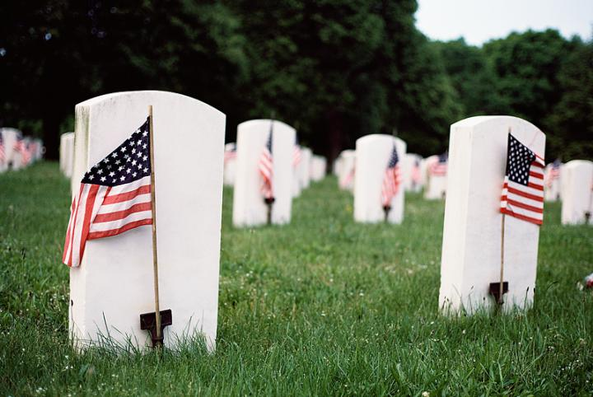
What is the meaning of Memorial Day, and how is this different from Veterans Day? Find Memorial Day history—plus, facts on poppies, poetry, and picnic recipes!

Memorial Day 2018
This U.S. federal holiday is celebrated on the last Monday of May to honor the men and women who have died while serving in the military.

Memorial Day History
The custom of honoring ancestors by cleaning cemeteries and decorating graves is an ancient and worldwide tradition, but the specific origin of Memorial Day, or Decoration Day as it was first known, are unclear.
In early rural America, this duty was usually performed in late summer and was an occasion for family reunions and picnics. After the Civil War, America’s need for a secular, patriotic ceremony to honor its military dead became prominent, as monuments to fallen soldiers were erected and dedicated, and ceremonies centering on the decoration of soldiers’ graves were held in towns and cities throughout the nation.
After World War I, the day expanded to honor those who have died in all American wars.
No less than 25 places have been named in connection with the origin of Memorial Day, and states observed the holiday on different dates. In 1971, Memorial Day became a national holiday by an act of Congress; it is now celebrated on the last Monday in May.
Since it all started with the Civil War, you might want to brush up on your knowledge of this event by visiting the Library of Congress Civil War collection, which includes more than a thousand photographs.

The Poppy, A Symbol of Memorial Day
The wearing of poppies in honor of America’s war dead is traditionally done on Memorial Day (not Veterans Day). The origin of the red poppy as a modern-day symbol of this day was actually the idea of an American woman, Miss Moina Michael. Read more about the inspiration for the poppy.
In war-torn battlefields, the red field poppy (papaver rhoeas) was one of the first plants to grow. Its seeds scattered in the wind and sat dormant in the ground, only germinating when the ground is disturbed—as it was by the very brutal fighting during World War 1.
The practice of wearing of poppies was further inspired by the poem “In Flanders Fields,” written in 1915 by Canadian soldier John McCrae. He saw the poppies in burials around his artillery position in Belgium.
Today, poppies are both the symbol of loss of life as a symbol of recovery and new life, especially in support of those servicemen who were damaged physically or emotionally.

Difference Between Memorial Day and Veterans Day
Many people confuse Memorial Day and Veterans Day. Memorial Day is a day for remembering and honoring military personnel who died in the service of their country, particularly those who died in battle or as a result of wounds sustained in battle.
While those who died are also remembered, Veterans Day is the day set aside to thank and honor ALL who served—in wartime or peacetime—and whether they died or survived. Veterans Day is always observed officially on November 11, regardless of the day of the week on which it falls.
Remember: Raise the flag in honor! Next week we will have the Flag Guidelines for you!

